POV Bike Wheel
Firmware & Upload Guide
MicroPython · VS Code · XIAO ESP32-S3

Part 1 — Set Up VS Code
You'll write all code on your MacBook in VS Code and upload it to the XIAO over USB-C. Two things to install before writing a single line.
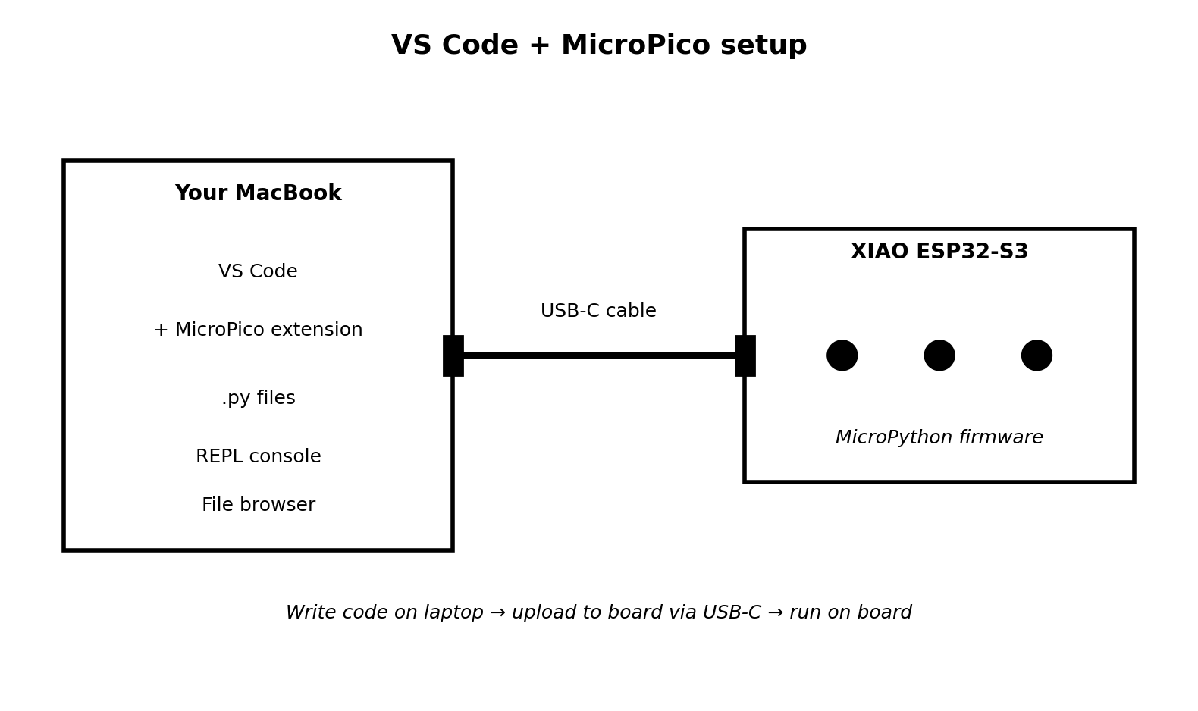
Figure 1 — VS Code talks to the XIAO via USB-C

Step 1.1 — Install the MicroPico extension
- Open VS Code → Extensions panel (⌘+Shift+X)
- Search: MicroPico by paulober
- Click Install
- Once installed, a small status bar item appears at the bottom of VS Code — this is your connection indicator

Step 1.2 — Flash MicroPython onto the XIAO
The XIAO ships with Arduino firmware. You need to replace it with MicroPython once — you never need to do this again.
- Go to micropython.org/download and download the Generic ESP32-S3 firmware (.bin file)
- Connect the XIAO to your MacBook via USB-C
- Put the board into bootloader mode: hold BOOT button, tap RESET, release BOOT
- In VS Code: open the Command Palette (⌘+Shift+P) → type MicroPico: Flash MicroPython
- Point it to the .bin file you downloaded and flash
- Reset the board. The MicroPico status bar should show Connected
💡 If the status bar shows Disconnected, check the USB-C cable is data-capable (not just a charging cable) and the correct serial port is selected in MicroPico settings.

Part 2 — Understand the File Structure
Your firmware lives in four .py files. Each has one job. You build and test them one at a time, not all at once.
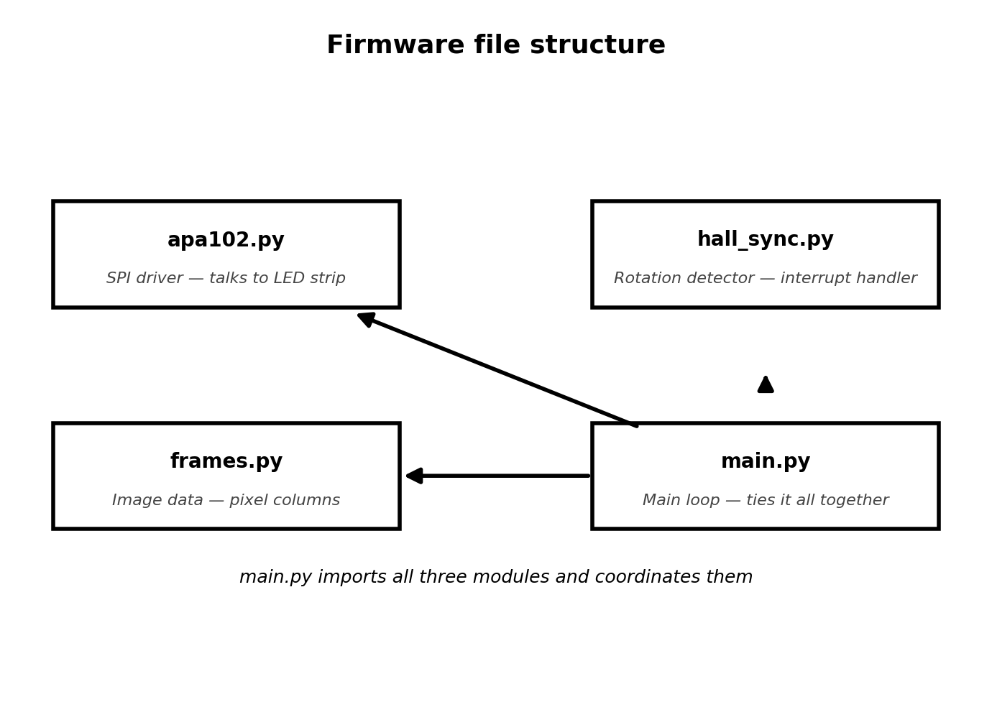
Figure 2 — four files, one job each
File summary:
- apa102.py — SPI driver. Knows how to talk to the SK9822 LED strip. You write it once and never touch it again.
- hall_sync.py — Interrupt handler. Listens for the hall sensor trigger and tracks rotation speed.
- frames.py — Your artwork. Contains the pixel data for every frame of your animation. This is the file you swap out when you change your design.
- main.py — The brain. Imports the other three and runs the main loop forever.
💡 Build and test each file independently before combining them. If something breaks in main.py, you'll already know the other three pieces work.

Part 3 — Write apa102.py (LED Driver)
This file handles the low-level SPI communication with the SK9822 strip. You write it once and it just works.
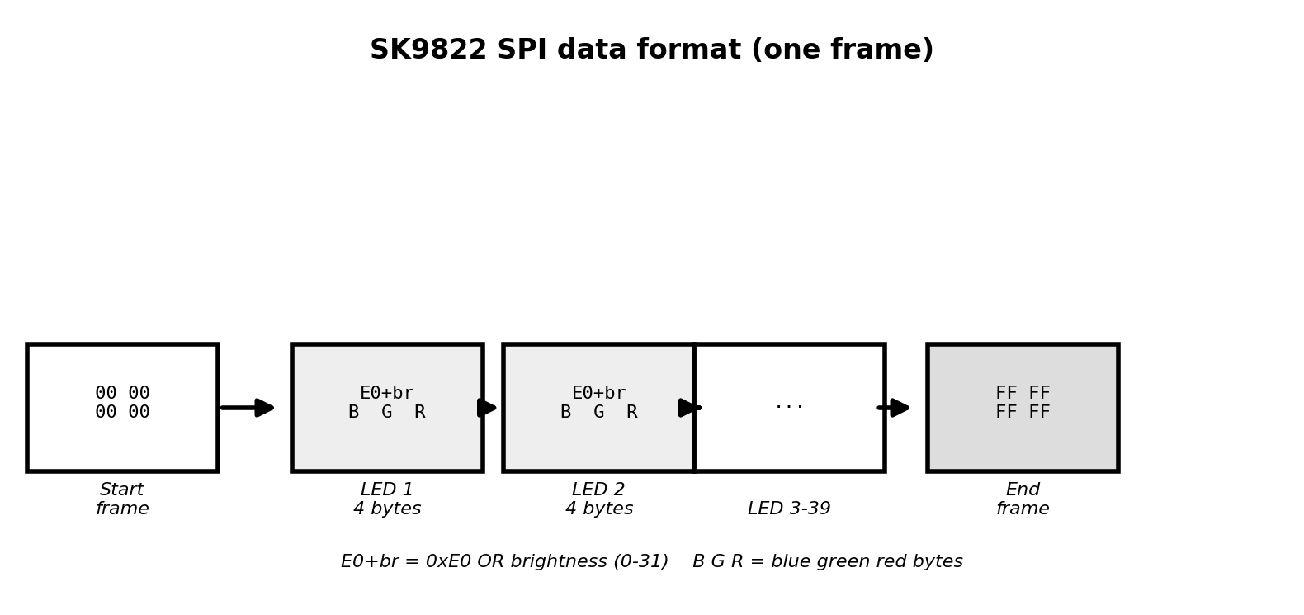
Figure 3 — SK9822 SPI data format

The code
from machine import SPI, Pin

class APA102:
def __init__(self, spi_id=1, sck_pin=7, mosi_pin=9,
num_leds=39, brightness=20):
self.num_leds = num_leds
self.brightness = brightness & 0x1F
self.spi = SPI(spi_id, baudrate=8_000_000,
polarity=0, phase=0,
sck=Pin(sck_pin), mosi=Pin(mosi_pin))

def show(self, pixels):
data = bytearray(4) # start frame
for r, g, b in pixels:
data += bytes([0xE0 | self.brightness, b, g, r])
data += bytes([0xFF] * ((self.num_leds // 16) + 1))
self.spi.write(data)

def off(self):
self.show([(0, 0, 0)] * self.num_leds)

Test it immediately after uploading
In the VS Code MicroPico REPL console at the bottom of the screen, type:
from apa102 import APA102
strip = APA102(num_leds=39)
strip.show([(255, 0, 0)] * 39) # should light all LEDs red
strip.show([(0, 255, 0)] * 39) # should light all LEDs green
strip.off() # should turn all off
If the strip lights up: wiring and SPI config are correct. Move on.
If nothing happens: check SCK and MOSI pin numbers match your actual wiring. The default pins (7 and 9) are for the XIAO ESP32-S3 — confirm against the board pinout printed on the back of the board.

Part 4 — Write hall_sync.py (Rotation Detector)
This file sets up a hardware interrupt on the hall sensor GPIO pin. Every time the magnet passes the sensor, it fires an interrupt that records the timestamp and calculates rotation speed.
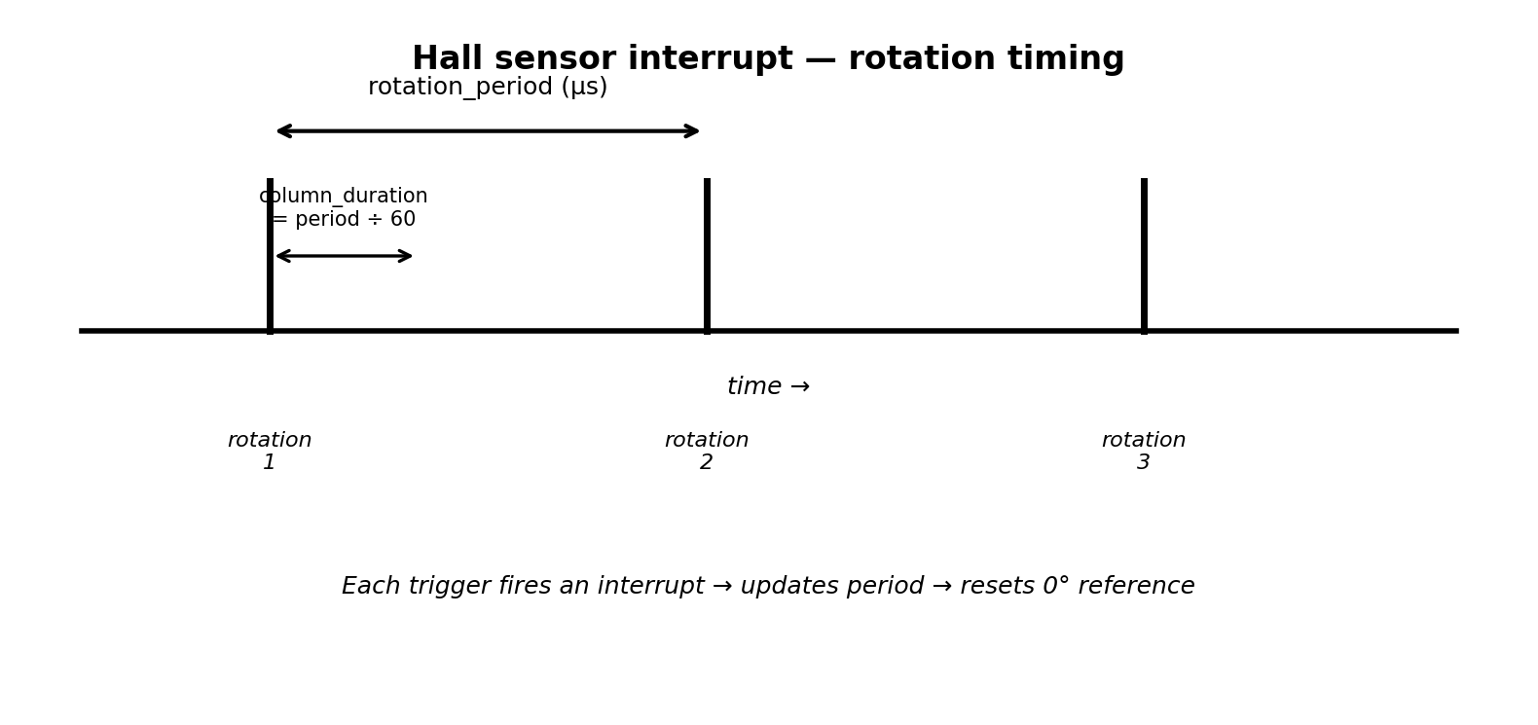
Figure 4 — rotation period measured between interrupt triggers

The code
from machine import Pin
import time

class HallSync:
def __init__(self, pin_num=3):
self.pin = Pin(pin_num, Pin.IN, Pin.PULL_UP)
self.last_time = time.ticks_us()
self.period_us = 0
self.rotation_count = 0
self.pin.irq(trigger=Pin.IRQ_FALLING,
handler=self._on_trigger)

def _on_trigger(self, pin):
now = time.ticks_us()
diff = time.ticks_diff(now, self.last_time)
if diff > 5000: # debounce: ignore <5ms gaps
self.period_us = diff
self.last_time = now
self.rotation_count += 1

def get_period(self):
return self.period_us

def is_spinning(self):
# no trigger in 1 second = wheel stopped
elapsed = time.ticks_diff(time.ticks_us(), self.last_time)
return elapsed < 1_000_000

Test it immediately after uploading
from hall_sync import HallSync
h = HallSync(pin_num=3)
# wave a magnet past the sensor several times, then:
print(h.rotation_count) # should increase each pass
print(h.period_us) # time between passes in microseconds
💡 If rotation_count stays at 0, check the GPIO pin number and confirm the sensor is wired correctly (VCC → 3.3V, GND → GND, OUT → GPIO pin).

Part 5 — Write frames.py (Image Data)
Start with a simple test pattern — alternating red and blue columns. This proves the timing works before you put real artwork in. Once everything runs, you replace this with real animation frames.

Test pattern first
NUM_COLUMNS = 60 # angular slices per rotation
NUM_LEDS = 39 # LEDs on your arm

def make_test_frame():
frame = []
for col in range(NUM_COLUMNS):
if col % 2 == 0:
color = (255, 0, 0) # red
else:
color = (0, 0, 255) # blue
frame.append([color] * NUM_LEDS)
return frame

FRAMES = [make_test_frame()]
💡 Once you see alternating red/blue stripes in the spinning wheel, the full system is working. Only then should you replace this with real artwork.

How to convert real images — run this on your MacBook
Design your artwork at exactly 60 x 39 pixels in any image editor (Photoshop, Figma, Pixelmator, even MS Paint). Export as PNG. Then run this Python script on your laptop — not on the XIAO.
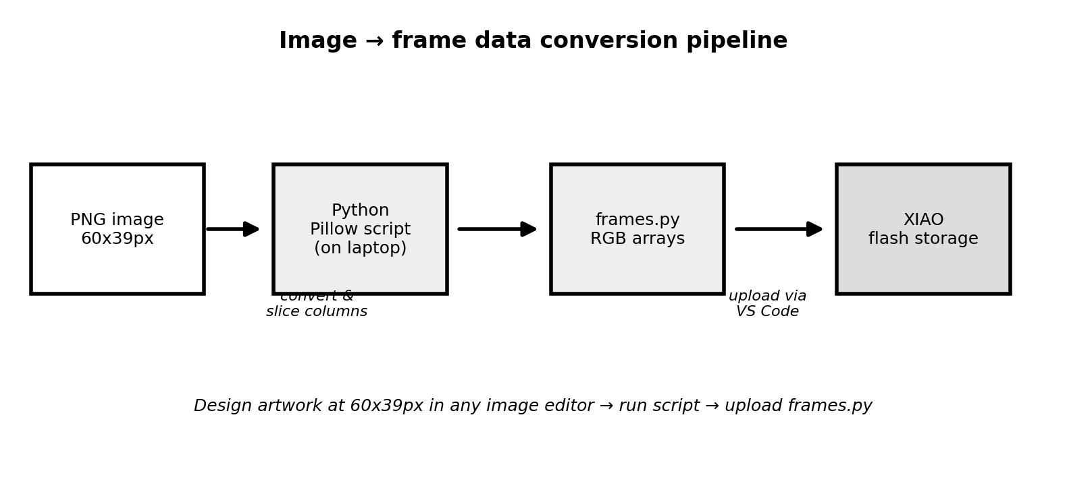
Figure 5 — laptop converts PNG to frames.py, then upload to board
# Run on your MacBook: python3 convert.py
# Requires: pip3 install pillow
from PIL import Image

NUM_COLUMNS = 60
NUM_LEDS = 39

def image_to_frame(path):
img = Image.open(path).convert('RGB')
img = img.resize((NUM_COLUMNS, NUM_LEDS))
frame = []
for col in range(NUM_COLUMNS):
column_pixels = []
for led in range(NUM_LEDS):
r, g, b = img.getpixel((col, led))
column_pixels.append((r, g, b))
frame.append(column_pixels)
return frame

def write_frames_file(paths, output='frames.py'):
with open(output, 'w') as f:
f.write(f'NUM_COLUMNS = {NUM_COLUMNS}\n')
f.write(f'NUM_LEDS = {NUM_LEDS}\n\n')
f.write('FRAMES = [\n')
for p in paths:
f.write(' ' + repr(image_to_frame(p)) + ',\n')
f.write(']\n')

# Example: one image (static)
write_frames_file(['my_logo.png'])

# Example: animated sequence
write_frames_file(['frame_01.png','frame_02.png','frame_03.png'])
This generates a new frames.py with your artwork baked in as raw pixel data. Upload it to the XIAO and reset the board — your new design loads automatically.
Part 6 — Write main.py (Main Loop)
main.py imports the other three modules and runs the POV loop forever. MicroPython automatically runs main.py on boot, so once this is on the board you just power it and it goes.
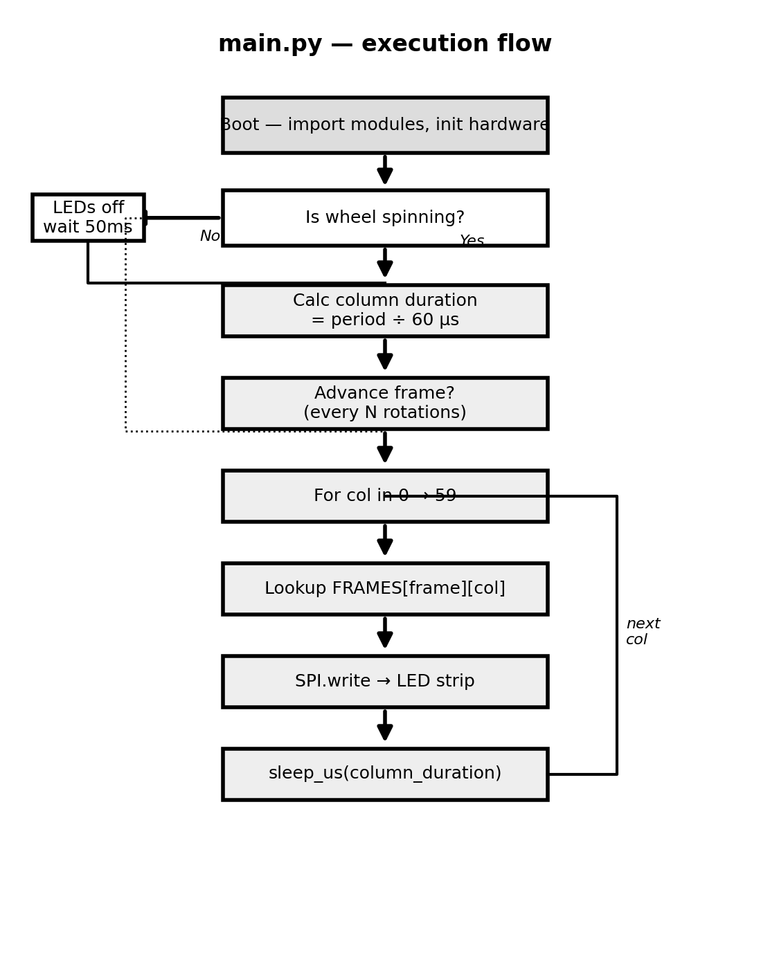
Figure 6 — main.py execution flow

The code
import time
from machine import Pin
from apa102 import APA102
from hall_sync import HallSync
from frames import FRAMES, NUM_COLUMNS, NUM_LEDS

# Hardware init
strip = APA102(num_leds=NUM_LEDS, brightness=20)
hall = HallSync(pin_num=3)
button = Pin(4, Pin.IN, Pin.PULL_UP) # kill switch button

# State
current_frame = 0
rot_at_last_frame = 0
ROTATIONS_PER_FRAME = 5
leds_on = True
last_btn = 0

def check_button():
global leds_on, last_btn
if button.value() == 0:
now = time.ticks_ms()
if time.ticks_diff(now, last_btn) > 300:
leds_on = not leds_on
if not leds_on:
strip.off()
last_btn = now

while True:
check_button()

if not leds_on or not hall.is_spinning():
strip.off()
time.sleep_ms(50)
continue

period = hall.get_period()
if period == 0:
time.sleep_ms(10)
continue

# advance animation frame
if hall.rotation_count - rot_at_last_frame >= ROTATIONS_PER_FRAME:
current_frame = (current_frame + 1) % len(FRAMES)
rot_at_last_frame = hall.rotation_count

column_dur = period // NUM_COLUMNS
frame = FRAMES[current_frame]

for col in range(NUM_COLUMNS):
t0 = time.ticks_us()
strip.show(frame[col])
elapsed = time.ticks_diff(time.ticks_us(), t0)
remaining = column_dur - elapsed
if remaining > 0:
time.sleep_us(remaining)

Part 7 — Upload All Files to the XIAO
With all four files written and individually tested, upload them to the board.

Method — VS Code MicroPico file browser
- Connect XIAO via USB-C and confirm MicroPico shows Connected in the status bar
- Open Explorer panel in VS Code (⌘+Shift+E)
- You'll see a MicroPico Device section at the bottom of the Explorer — this shows the board's filesystem
- Right-click each .py file in your project → Upload to MicroPico
- Upload in this order: apa102.py → hall_sync.py → frames.py → main.py
- Press the RESET button on the XIAO — main.py runs automatically
💡 To update artwork only: regenerate frames.py on your laptop → upload just frames.py → reset. You do not need to re-upload the other three files.

Updating later without a USB cable — OTA via WiFi
Once wheel #1 is validated and riding, you can push new frames.py files to both wheels over WiFi from your phone or laptop at camp — no cable, no removing the wheel. This is covered in the WiFi sync extension to main.py.

Quick Troubleshooting Reference
Most issues fall into one of these categories:
- MicroPico shows Disconnected → wrong USB cable (use data cable, not charge-only), or wrong serial port in MicroPico settings
- LEDs don't light after apa102.py test → wrong SCK/MOSI pin numbers. Check XIAO pinout diagram and update spi_id, sck_pin, mosi_pin in APA102.__init__
- hall.rotation_count never increases → wrong GPIO pin number, or sensor not wired correctly (needs 3.3V not 5V for VCC)
- Image blurry/smeared → lower NUM_COLUMNS from 60 to 40 and test again. Column timing too tight for current rotation speed.
- Image shifts position each rotation → magnet/sensor gap inconsistent. The arm may be wobbling. Tighten zip ties.
- Board resets randomly while spinning → power brownout. Check MT3608 is outputting stable 5V under full LED load with a multimeter.
- SyntaxError on boot → typo in one of the .py files. Check the REPL output in VS Code — it prints the exact line number.
- ModuleNotFoundError: no module named apa102 → file wasn't uploaded to the board. Re-upload via MicroPico file browser.

